**Step-by-step tutorial Phenotyper (room 251)**

1. On the computer:
   * Insert Noldus dongle (2211, 2212, 2214) in computer before using Ethovision
   * Switch on Ethovision software (latest version, e.g. 14)
   * File > Open > Template cognition wall > Save as > Your location and experiment name

(use: USERS/BAGNI/Adrian/Template A/B .evxt file)

* + To check whether the pellet dispensers work:
    - Go to Arena Settings > Wall, Bottom right “Arena – Hardware Mapping” to test pellet dispensers

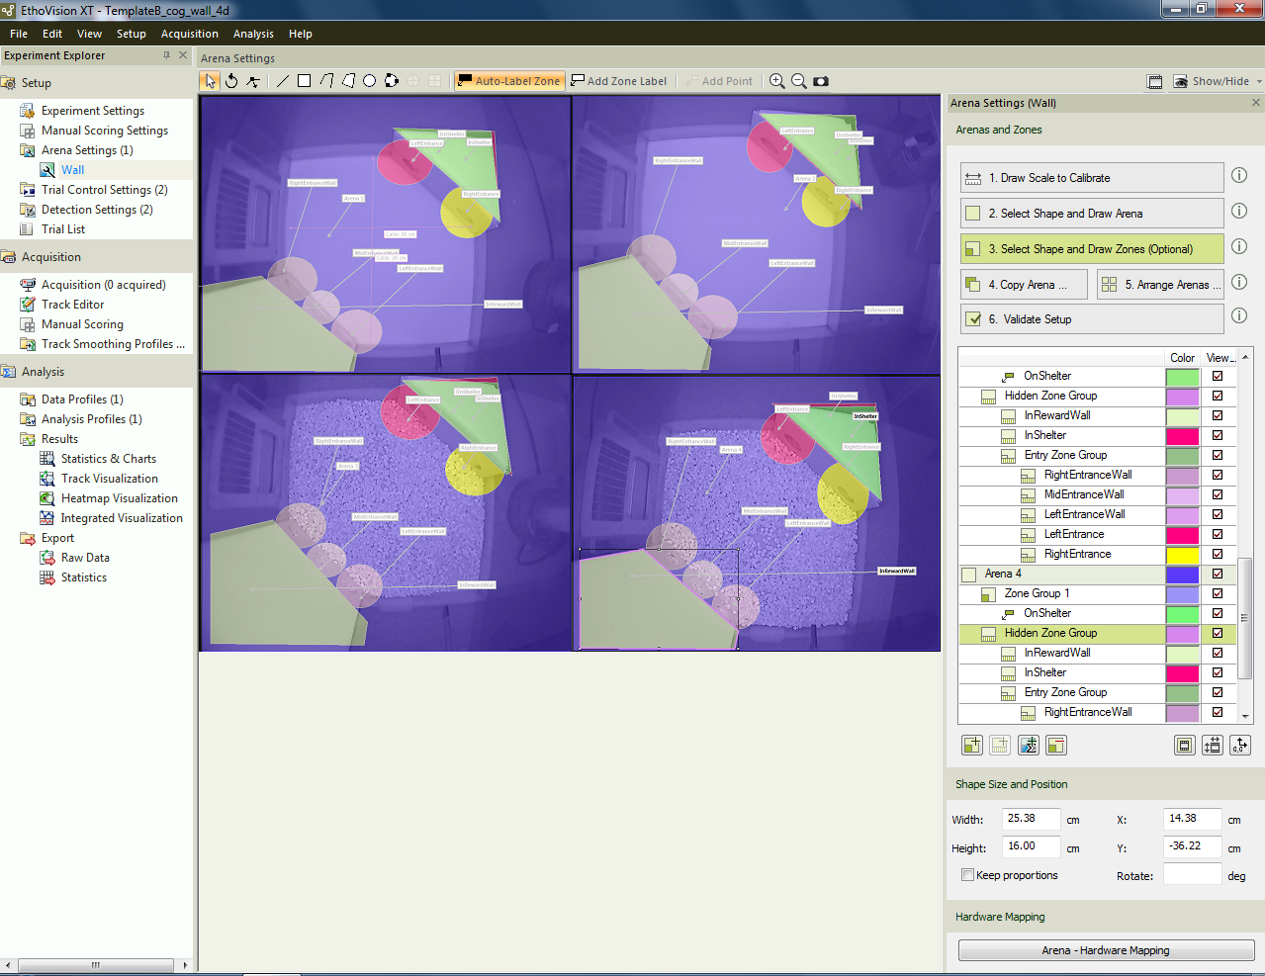

* + - Highlight one of the pellet dispensers and click “Test”

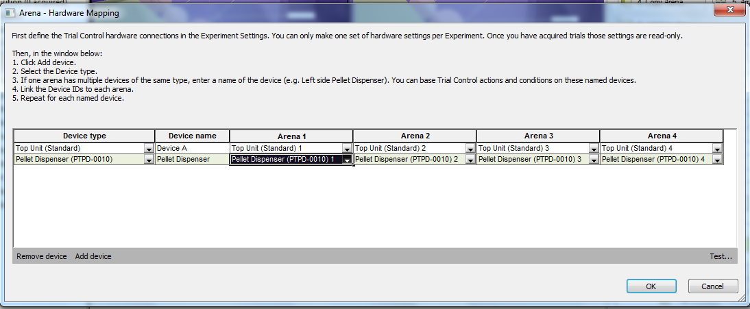

* + - For the command “Drop Pellet”, click “Test”. You would hear a rotor moving and a pellet coming out. Try several times, if all times a pellet comes out. Then move on the next pellet dispenser and repeat.

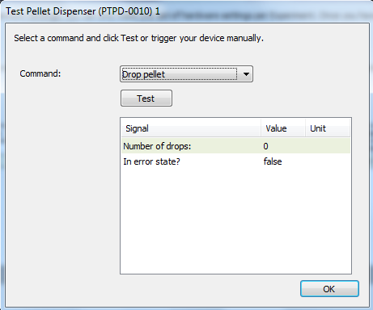

* + Go to Trial list and fill in all fields as shown below: Arena settings, Trial control settings, detection settings and pyrat id.

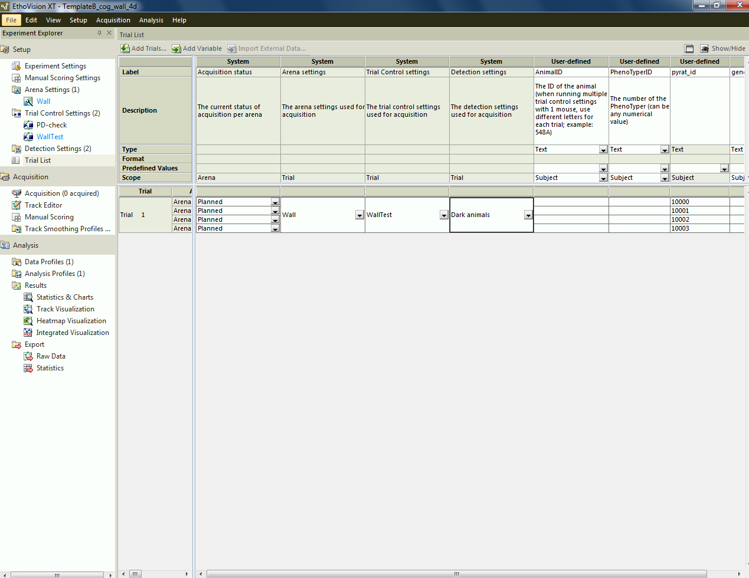

1. Switch on all overheads (4 chambers on the left (pc B) and the right side of the room (pc A)). Even if you will not use all chambers, it is recommended to switch them also on, thus to reduce the size of the data files. A switched off overhead would create a lot of “movements” based on detection settings and thus “data”.
   * Place first all the houses in the chamber.
   * Push one sheet of Kleenex paper in the house (nesting material).
   * Fill each chamber with one cup of white bedding. Bedding does not have to go into the house. Flatten it.
   * Insert the tube of the pellet dispenser (in case of FVB mice, already place this tube during the habituation as they would otherwise start to bite the plastics). Make sure that the tube goes smoothly as to allow pellet to move down easier.
   * Prepare one bottle of water for each chamber and GENTLY push into its position. Be aware that you could spill and remove all electronics or previous items below the border of the table.
2. Put the mice according to their ID into the Phenotyper chambers between 10 and 11am. Balance the number of WT and Mutant mice on each side (pc A and B).
3. Place carton dividers between the Phenotyper chambers, so the mice would not be disturbed by each other.
4. Remove the Ethernet cable before running the experiment (removing the Ethernet cable does not allow the computer to automatically update during the experiment).
5. Let the mice habituate till 4pm, before adding the Cognition wall into the chamber.
   * Remove the white bedding in the area where the cognition wall would be placed.
   * Add the cognition wall
   * Insert the tube of the pellet dispenser (in case of FVB mice, already place this tube during the habituation as they would otherwise start to bite the plastics). Make sure that the tube goes smoothly as to allow pellet to move down easier.
   * Flatten the white bedding in front of the cognition wall
   * Go to the computer and in Arena settings > wall > right click to grab the current background image

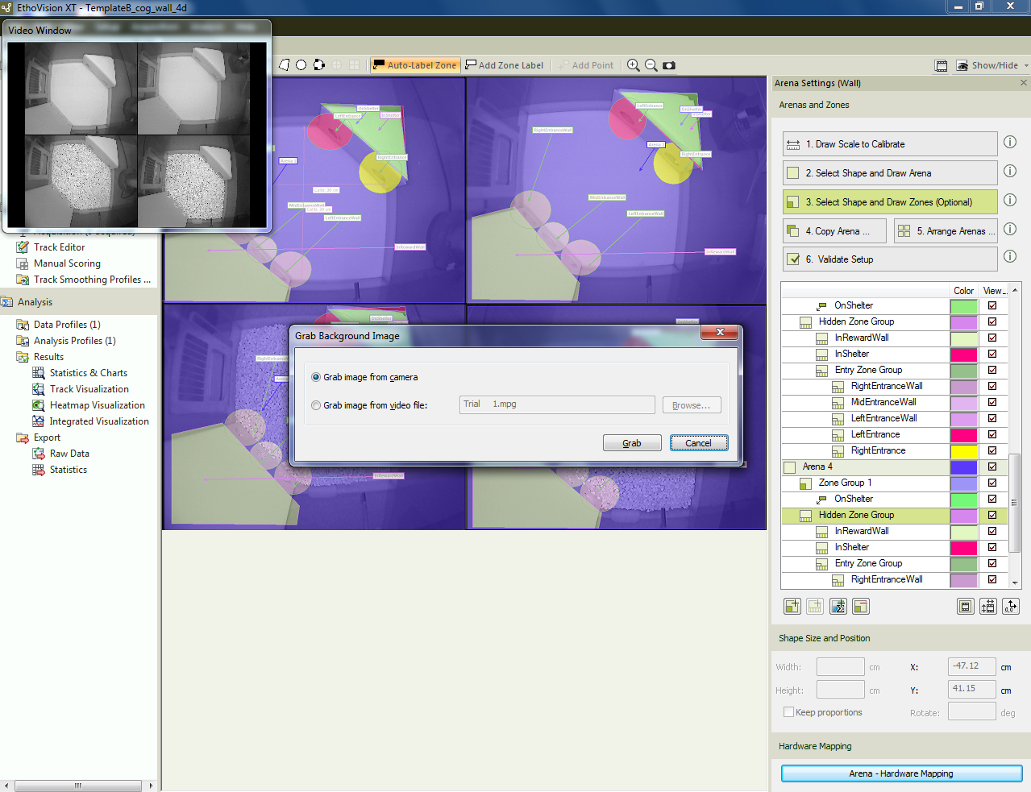

* + Go to acquisition, and make sure that there are no yellow areas detected outside of the chamber. If yes, with a dark glove go over that area next to the chamber to remove the yellow detection.
  + Once all is done. Check whether the “save video” box is unticked (top right). Press the red button “ready to start”. The software would automatically initiate at 4.30pm

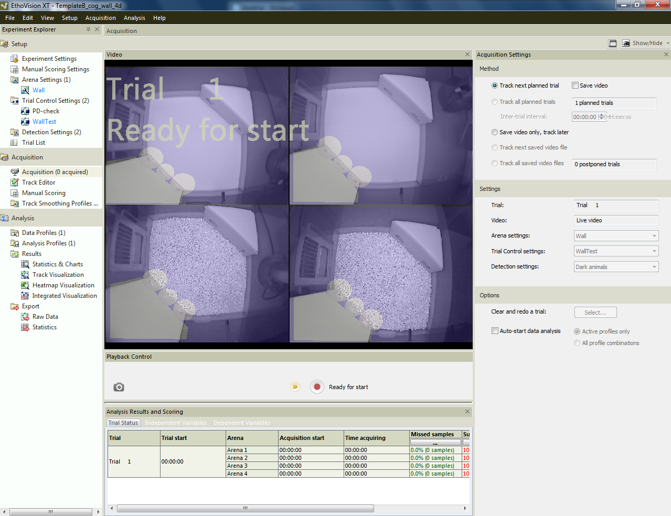

* + Switch off the computer screens and leave the dark-light cycle lights on.

1. Around 4.45pm, go to check quietly whether the software is running nicely.
2. The experiment runs for 4 days, but we cut off at 90 hours. At the fourth day just after 10am, you can terminate the experiment and remove the animals. Clean the walls and houses with soup and the chambers with 5% EtOH.
3. Plug back in the Ethernet cable to allow access to the NAS.
4. To save the experiment:
   * File > Make backup > untick “include media files”
   * Save the backup as well as the full experiment on the NAS. Instructions for how to connect to the NAS are described next to the computer.
   * Once everything is saved on the NAS. Remove the files on the experiment computer (so not to overload the memory space).
5. If you run a next batch of mice after the current batch, they have to enter the latest at 11am.
6. To extract data:
   * Use a dongle on your computer with Ethovision (otherwise run on the computer in the Phenotyper room) and open Ethovision.
   * Go to file > restore backup > add file to desktop or other location on your computer (later you can move them to the NAS)
   * Go to Analysis > Export > Raw Data
   * Indicate that the file type is ANSI
   * Start export of data
   * (switch off sleep mode)
   * **DO NOT USE OR LET THE COMPUTER SLEEP DURING TIME OF EXPORT**
   * Once raw data are extracted, save these in a dedicated folder (e.g. Adrian-2020-10-10-Fmr1 FVB-cw)
7. For analysis:
   * Prepare an excel file called “MouseList_cw.xlsx” with the following information:
     + Batch
     + Pyrat_id
     + Sylics_id
     + Condition_1
     + Condition_2
     + Arena
     + Trial
     + Filename: only the name, “.txt” is not required
     + QC
     + Comments

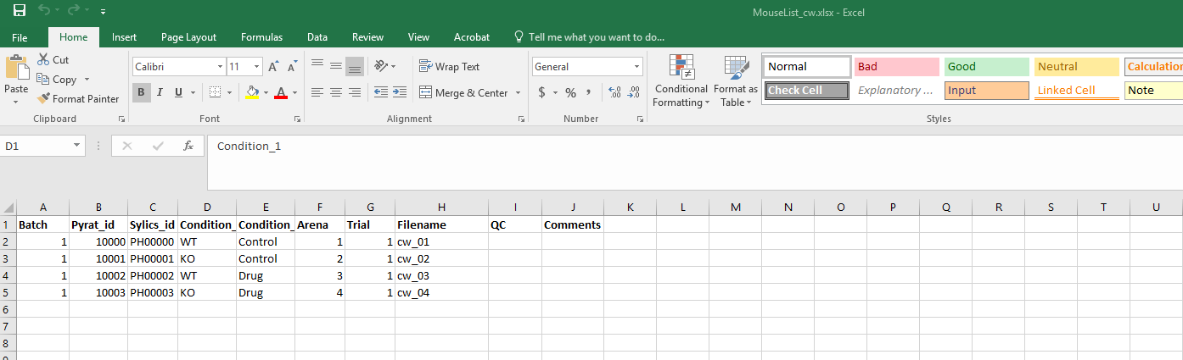

* + This is the metafile. Place this excel file in folder created in step 9

1. Go to RStudio
   * open project “phenotyper.Rproj”
   * open cw_pipeline
   * Press source and go to the folder that contains all the text raw data and excel metafile. Wait for the analyses to be ready